Meeting hears about plan to address Nipawin housing needs
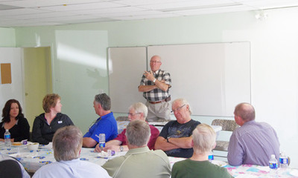
Habitat for Humanity Prince Albert President Morris Sawchuk speaks during a meeting at the Nipawin Oasis Centre on Monday, May 16, 2011
Nipawin families in need of housing might soon be able to become homeowners if a new initiative gets the support of the community.
Business and community representatives learned more about the approach followed by Habitat for Humanity to provide families with affordable housing at a meeting hosted by the Oasis Centre on Monday, May 16.
Morris Sawchuk, the president of Habitat for Humanity Prince Albert, was the guest speaker at the noon hour meeting. He spoke about the work done by the organization in Prince Albert and their interest in a community partnership with Nipawin.
"The community has to become a partnership with the Habitat organization to make this work and that's what we've done in Prince Albert," he said.
Habitat for Humanity Prince Albert started in 1993. From a slow start that only saw it building a house every second or third year the organization has successfully evolved to where they are building three houses a year and they have plans for five houses next year.
The Habitat for Humanity approach has been used with success in countries across the world to provide homes for low-income families through the use of volunteer labour. Partner families are required to provide 500 hours of "sweat equity" in building their own home or someone else's home. In return they receive an opportunity to become homeowners through an interest free, no down payment mortgage.
"The reason it works is because it's a hand-up, not a handout," Sawchuk said. "If you get something for nothing it doesn't work, people do not appreciate it. But if they have to put in an effort then they appreciate it."
He said it is important to build at least one house per year to keep momentum and to prevent people from getting discouraged. He emphasized that Habitat for Humanity is a very transparent organization with very little money going towards administration because volunteers do most of the work.
"The money goes truly towards building more homes," he said.
According to Sawchuk the Habitat for Humanity Prince Albert affiliate has been looking at developing a partnership with other communities in the area for some time, but Nipawin was the first community to approach them.
However, Nipawin will not be able to create its own affiliate due to Habitat for Humanity requirements for the size of the community, which must have a population of 100,000 or more (a requirement that was not in place when the Prince Albert affiliate was established).
If it is something the community would like to pursue, Nipawin will have to sign an agreement with the Prince Albert affiliate, who will provide support and advice with regard to fundraising efforts and partnerships.
Nipawin Mayor Lawrence Rospad, who attended the presentation, told the meeting the town's contribution towards the initiative would be to provide infill lots at no cost for the construction of the homes.
"We've had quite a few discussions already with council members. These lots right now have no revenue being produced for taxation, so we see this as a great opportunity to rejuvenate neighbourhoods and we just think it's a fantastic project and opportunity."
Oasis Centre CEO Chris Hudyma said the centre's role is to help facilitate the initiative to bring Habitat for Humanity to Nipawin and they would also like to remain involved as a partner.
According to him the Oasis Centre decided to approach Habitat for Humanity Prince Albert as a result of the need for housing that were expressed by people who make use of the services at the centre.
"There's a strong indication that there's interest from the community," he said after the meeting.
Hudyma said another public forum meeting would be held within the next few weeks to discuss the creation of community partnerships and the establishment of a committee.

